**Cognition and Learning Needs**

The SEND Code of Practice describes this as: ‘Support for learning difficulties may be required when children and young people learn at a slower pace than their peers, even with appropriate differentiation. Learning difficulties cover a wide range of needs, including moderate learning difficulties (MLD), severe learning difficulties (SLD), where children are likely to need support in all areas of the curriculum and associated difficulties with mobility and communication, through to profound and multiple learning difficulties (PMLD), where children are likely to have severe and complex learning difficulties as well as a physical disability or sensory impairment. Specific learning difficulties (SpLD), affect one or more specific aspects of learning.

This encompasses a range of conditions such as dyslexia, dyscalculia and dyspraxia.

All children’s needs are best met by high-quality adaptive teaching based on children’s prior knowledge, promoting independence, taking account each child’s needs, with in-built support and challenge. Quality teaching is informed by assessment, and quality marking and feedback. It includes an inclusive learning environment, interventions, support from trained teaching assistants and specific resources to target individual need.

**Class strategies**

Psychologist (EP) or the Communication, Learning and Autism Support Service (CLASS)

**Group or 1:1 support**

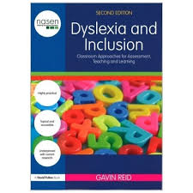

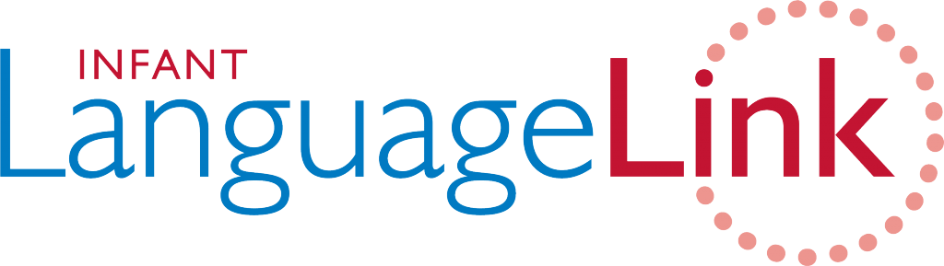

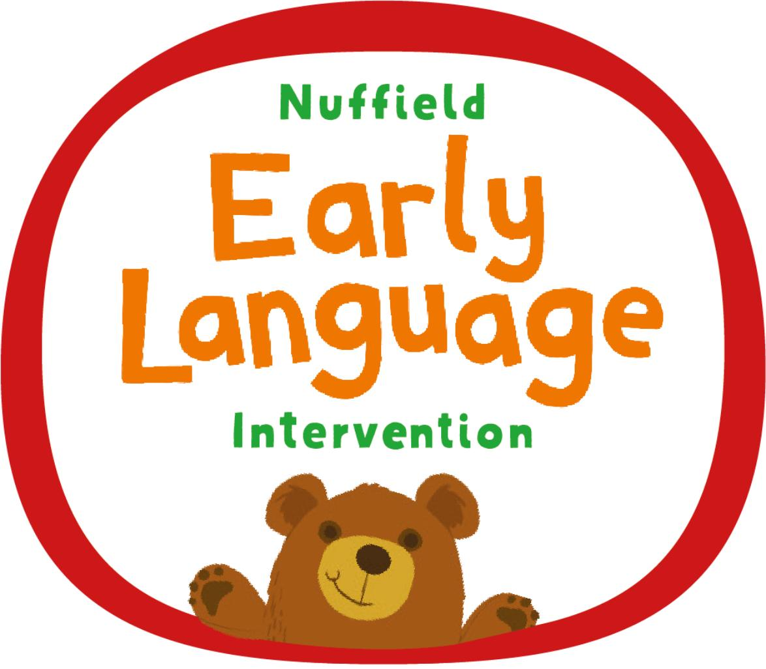

Some children may be identified, through screening, as requiring additional support. This may include phonics, spelling, reading, writing or maths interventions. These will be provided by the class teacher, support staff or Nurture Lead.

All children in Reception are screened through NELI, and in year 1 through Infant Language Link. They are screened again in year 3 through Junior Language Link, the Helen Arkell Spelling Test and, where required, COLIN to indicate any potential difficulties with processing or working memory. In consultation with parents, children may then have further assessments including but not limited to DST for Dyslexia in years 5 and 6. following British Psychological Society recommendations.

**Referrals**

Referrals are required for:

* Consultation with Educational Psychologist (EP) – with teachers, direct work with children is no longer available.
* Consultation with Communication, Learning and Autism Support Service (CLASS) – with class teachers, direct work with children is no longer available.

Please discuss any worries that you have about your child with their class teacher, then the SENCO if High Quality Teaching and intervention does not impact.

**Screenings**

request specialist support from an Educational

A few children may require referral to

**EP**

**CLASS**

**Cognition and learning needs**

